**Spring Data JPA with Spring Boot, Hibernate**

**1. Spring Data JPA - Quick Example**

**application.properties:**

spring.application.name=orm-learn

spring.datasource.url=jdbc:mysql://localhost:3306/ormlearn

spring.datasource.username=root

spring.datasource.password=root

spring.datasource.driver-class-name=com.mysql.cj.jdbc.Driver

spring.jpa.hibernate.ddl-auto=update

spring.jpa.show-sql=true

spring.jpa.properties.hibernate.dialect=org.hibernate.dialect.MySQL8Dialect

# Logging

logging.level.org.springframework=info

logging.level.com.cognizant=debug

logging.level.org.hibernate.SQL=trace

logging.level.org.hibernate.type.descriptor.sql=trace

logging.pattern.console=%d{dd-MM-yy} %d{HH:mm:ss.SSS} %-20.20thread %5p %-25.25logger{25} %25M %4L %m%n

**pom.xml file:**

<?xml version="1.0" encoding="UTF-8"?>

<project xmlns="http://maven.apache.org/POM/4.0.0"

xmlns:xsi="http://www.w3.org/2001/XMLSchema-instance"

xsi:schemaLocation="http://maven.apache.org/POM/4.0.0 https://maven.apache.org/xsd/maven-4.0.0.xsd">

<modelVersion>4.0.0</modelVersion>

<parent>

<groupId>org.springframework.boot</groupId>

<artifactId>spring-boot-starter-parent</artifactId>

<version>3.5.3</version>

<relativePath/>

</parent>

<groupId>com.cognizant</groupId>

<artifactId>orm-learn</artifactId>

<version>0.0.1-SNAPSHOT</version>

<name>orm-learn</name>

<description>Demo project for Spring Data JPA and Hibernate</description>

<properties>

<java.version>17</java.version>

</properties>

<dependencies>

<dependency>

<groupId>org.springframework.boot</groupId>

<artifactId>spring-boot-starter-data-jpa</artifactId>

</dependency>

<dependency>

<groupId>org.springframework.boot</groupId>

<artifactId>spring-boot-starter-web</artifactId>

</dependency>

<dependency>

<groupId>com.mysql</groupId>

<artifactId>mysql-connector-j</artifactId>

<scope>runtime</scope>

</dependency>

<dependency>

<groupId>org.springframework.boot</groupId>

<artifactId>spring-boot-devtools</artifactId>

<scope>runtime</scope>

<optional>true</optional>

</dependency>

<!-- Testing -->

<dependency>

<groupId>org.springframework.boot</groupId>

<artifactId>spring-boot-starter-test</artifactId>

<scope>test</scope>

</dependency>

</dependencies>

<build>

<plugins>

<!-- Spring Boot Plugin -->

<plugin>

<groupId>org.springframework.boot</groupId>

<artifactId>spring-boot-maven-plugin</artifactId>

</plugin>

</plugins>

</build>

</project>

**Schema Creation:**

create schema ormlearn;

use ormlearn;

**Country table creation:**

create table country(co_code varchar(2) primary key, co_name varchar(50));

insert into country values ('IN', 'India');

insert into country values ('US', 'United States of America');

**PERSISTENCE CLASS**

**Country.java (com.cognizant.orm-learn.model.Country)**

package com.cognizant.orm_learn.model;

import jakarta.persistence.Column;

import jakarta.persistence.Entity;

import jakarta.persistence.Id;

import jakarta.persistence.Table;

@Entity

@Table(name = "country")

public class Country {

@Id

@Column(name = "code")

private String code;

@Column(name = "name")

private String name;

public String getCode() {

return code;

}

public void setCode(String code) {

this.code = code;

}

public String getName() {

return name;

}

public void setName(String name) {

this.name = name;

}

@Override

public String toString() {

return "Country [code=" + code + ", name=" + name + "]";

}

}

**REPOSITORY CLASS**

**CountryRepository.java (com.cognizant.orm-learn.CountryRepository)**

package com.cognizant.orm_learn.repository;

import org.springframework.data.jpa.repository.JpaRepository;

import org.springframework.stereotype.Repository;

import com.cognizant.orm_learn.model.Country;

@Repository

public interface CountryRepository extends JpaRepository<Country, String>{

}

**SERVICE CLASS**

**CountryService.java (com.cognizant.orm-learn.service.CountryService)**

package com.cognizant.orm_learn.service;

import java.util.List;

import org.springframework.beans.factory.annotation.Autowired;

import org.springframework.stereotype.Service;

import com.cognizant.orm_learn.model.Country;

import com.cognizant.orm_learn.repository.CountryRepository;

import jakarta.transaction.Transactional;

@Service

public class CountryService {

@Autowired

private CountryRepository countryRepository;

@Transactional

public List<Country> getAllCountries() {

return countryRepository.findAll();

}

}

**OrmLearnApplication.java**

package com.cognizant.orm_learn;

import java.util.List;

import org.slf4j.Logger;

import org.slf4j.LoggerFactory;

import org.springframework.boot.SpringApplication;

import org.springframework.boot.autoconfigure.SpringBootApplication;

import org.springframework.context.ApplicationContext;

import com.cognizant.orm_learn.model.Country;

import com.cognizant.orm_learn.service.CountryService;

@SpringBootApplication

public class OrmLearnApplication {

private static final Logger LOGGER = LoggerFactory.getLogger(OrmLearnApplication.class);

private static CountryService countryService;

public static void main(String[] args) {

ApplicationContext context = SpringApplication.run(OrmLearnApplication.class, args);

LOGGER.info("Inside main");

countryService = context.getBean(CountryService.class);

testGetAllCountries();

}

private static void testGetAllCountries() {

LOGGER.info("Start");

List<Country> countries = countryService.getAllCountries();

LOGGER.debug("countries={}", countries);

LOGGER.info("End");

}}

**OUTPUT:**

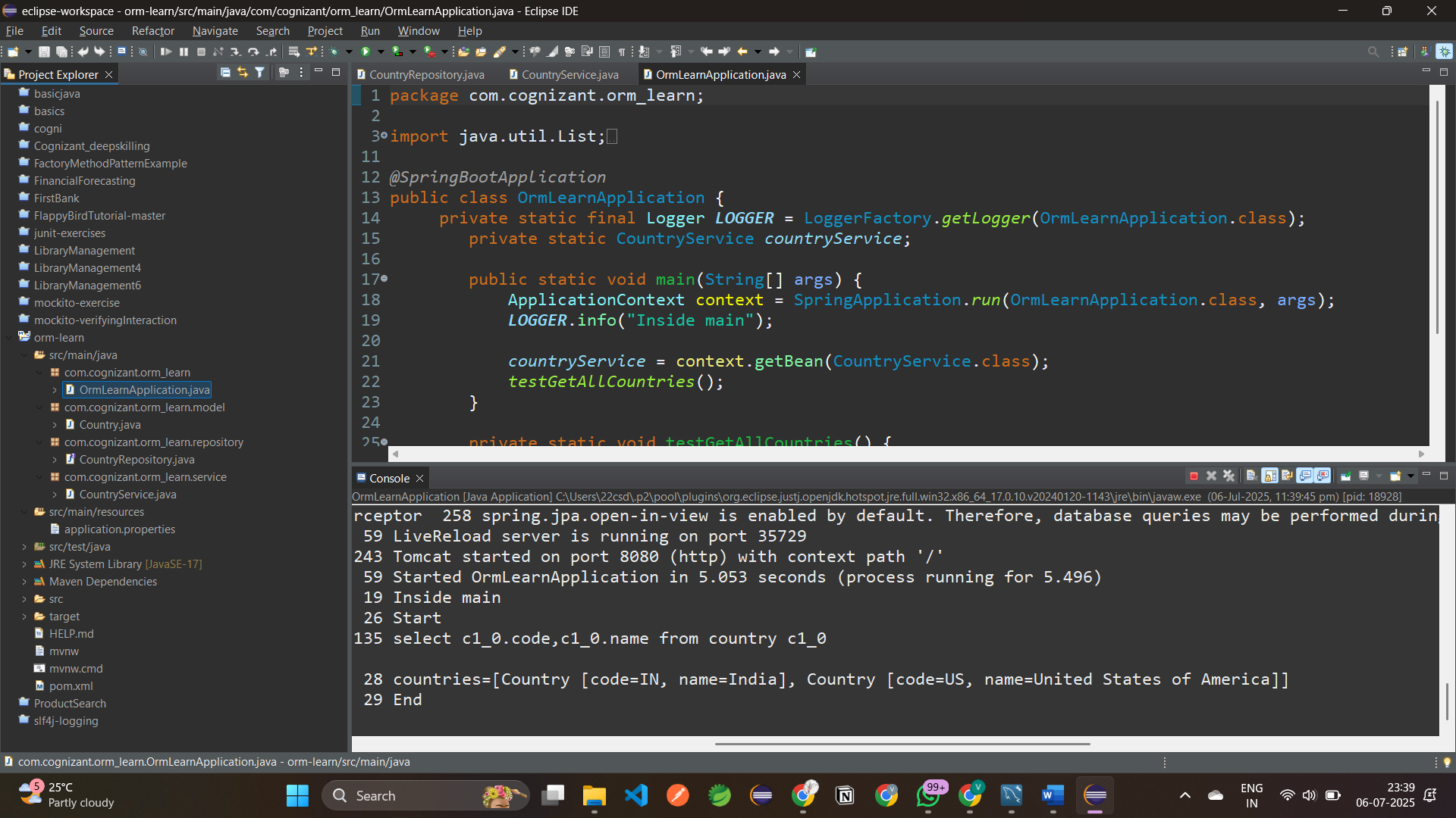

**MySQL Database:**

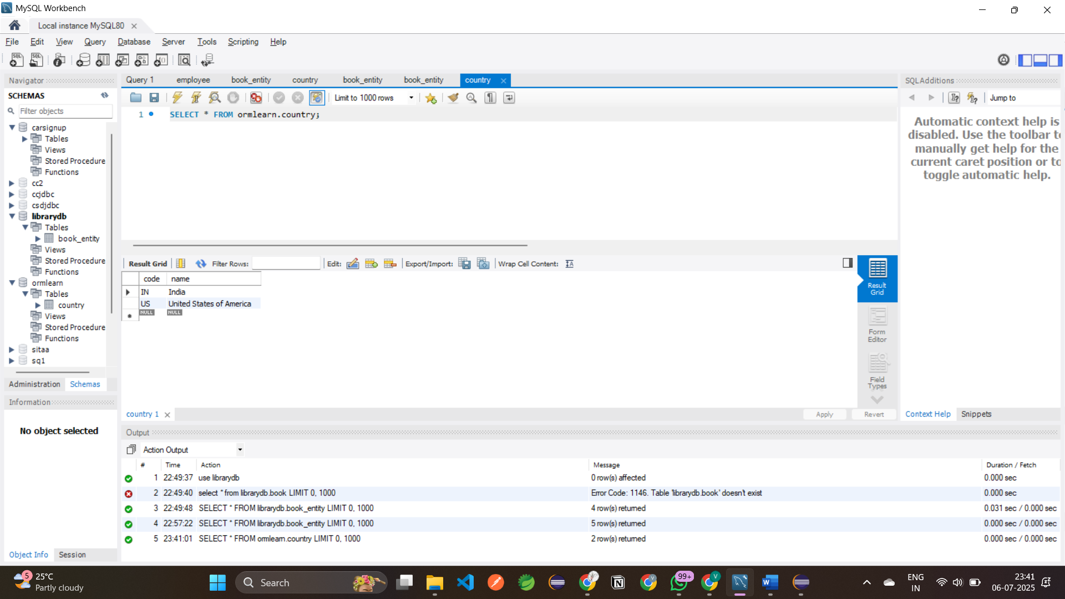

**4. Difference between JPA, Hibernate and Spring Data JPA**

**Java Persistence API, or JPA:**JSR 338 is a specification that outlines the proper way to persist Java objects to a relational database.

It defines annotations and interfaces to persist, retrieve, and manage Java objects.

JPA itself does **not contain implementation**.

It requires an implementation provider like **Hibernate**, **EclipseLink**, etc

**Hibernate:**

Hibernate is an ORM (Object-Relational Mapping) tool that provides a concrete implementation of the JPA specification.

It also offers additional features beyond the JPA spec like caching, lazy loading, etc.Developers can use Hibernate in two ways:

* **JPA-compliant** (EntityManager, @Entity)
* **Native Hibernate APIs** (Session, Transaction, etc.)

**JPA for Spring Data:**Spring Data JPA is a **high-level abstraction** built on top of JPA (and indirectly on Hibernate).

It allows developers to write **less boilerplate code**.

It provides powerful features like:

* Auto-implemented query methods (e.g., findByName)
* Pagination and sorting
* Transaction management

Internally uses Hibernate or any JPA provider.

Reduces boilerplate through transaction management and query generation automation.

**CODE COMPARISON:**

**1.Hibernate Code: (Manual Session & Transaction)**

public Integer addEmployee(Employee employee){

      Session session = factory.openSession();

      Transaction tx = null;

      Integer employeeID = null;

      try {

         tx = session.beginTransaction();

         employeeID = (Integer) session.save(employee);

         tx.commit();

      } catch (HibernateException e) {

         if (tx != null) tx.rollback();

         e.printStackTrace();

} finally {

         session.close();

      }

      return employeeID; }

**hibernate.cfg.xml**

<hibernate-configuration>

<session-factory>

<property name="hibernate.connection.driver_class">com.mysql.cj.jdbc.Driver</property>

<property name="hibernate.connection.url">jdbc:mysql://localhost:3306/test</property>

<property name="hibernate.connection.username">root</property>

<property name="hibernate.connection.password">root</property>

<property name="hibernate.dialect">org.hibernate.dialect.MySQL5Dialect</property>

<mapping resource="Employee.hbm.xml"/>

</session-factory>

</hibernate-configuration>

**2. Spring Data JPA (Repository Abstraction)**

**EmployeeRepository.java**

public interface EmployeeRepository extends JpaRepository<Employee, Integer> {

}

**EmployeeService.java**

@Autowired

private EmployeeRepository employeeRepository;

@Transactional

public void addEmployee(Employee employee) {

employeeRepository.save(employee);

}

**3. Summary Table:**

| **Feature** | **JPA** | **Hibernate** | **Spring Data JPA** |
| --- | --- | --- | --- |
| Type | Specification | Implementation of JPA | Abstraction over JPA + Hibernate |
| Boilerplate Code | Medium | High | Low |
| Manages Transactions | No | No | Yes (via Spring) |
| Custom Queries | Not applicable | Yes | Yes (JPQL, Query Methods, @Query) |
| Learning Curve | Moderate | Moderate to High | Easy to Moderate |